CONNECTION POWER EXPORT OF MEMBER INFO
Within the Powermember module, select the “Query/Export” option.
For the member info, you will want to select “Individuals” and in most cases the Comma Separated File (CSV) format is the easiest to use. It is readable by Excel and often is a smaller download file size.
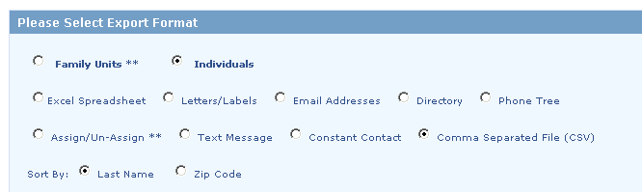
If you want to download info from all of your CP modules, you can select the “ALL” option in the left box. Then you need to decide if you want to download all of your member info or just those that are currently “Active”. 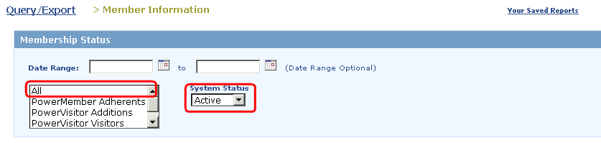
You can select “ALL” 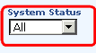in the right System Status and it will download all of the records so that you have them for future reference. You can always sort by the System Status field in the downloaded file if you only want to upload “active” member info into the new software provider.
Then you will want to scroll through the next section to be sure you have not filtered any data fields that would limit the information that is exported for you.
After all of the filter section… you will find the “EXPORT FIELDS” section.
You will note the fields on the next screen shot that are highlighted in yellow are key fields that most churches will want to bring over to the new database. Note: You do not need the (*Org. Member Id or *Org Family ID) which was the id code from whatever database program you used before Connection Power which will have no benefit to the new database.

The Family ID and the Member ID fields are very important.
You may want to create one export that selects all of the fields that you have information stored in. This will provide you with a worksheet that you can later go back to refer to if you need info.
Then you may want to create a separate download of only those fields that you plan to import into the new database format to make it smaller and easier to use.
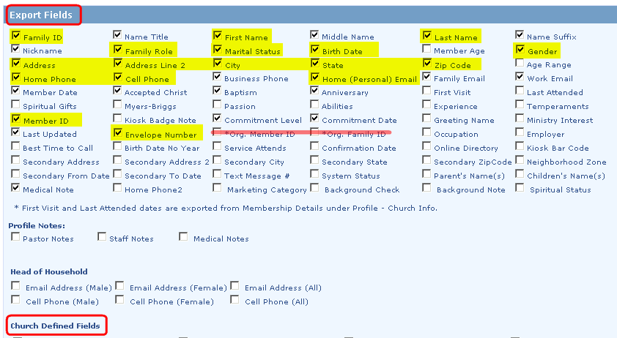
In the screen above you will note that Connection Power did allow for “Church Defined Fields”. If you had any special fields that you had defined for your church then you may want select all of them as well for your general export for future reference.

Then scroll to the bottom of the screen and you will see the options to Save as Report.
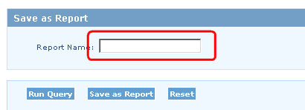
You can enter a report name and then “Save as Report”. This will save the settings in case you want to come back and make adjustments. If you “Save as Report”… you will then need to select the “Query/Export” option on the top of the screen and then select the “Your Saved Reports” option on the top right. This will list out all of your saved reports. Simply select the report you want to report and select at the bottom that you want to save as “CSV” or “EXCEL”.
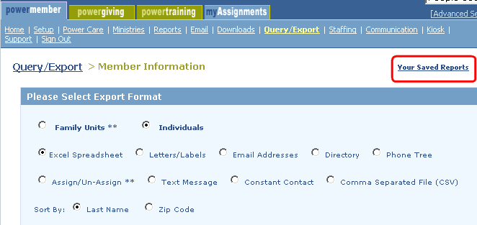
This should then begin the report generation process. If you have a large church or have selected a large number of fields, this process can take some time. If you cannot get the export to work, you may have to create two reports. Be sure to include in both reports the “Member ID” and “Family ID” fields as well as the name info. This will enable the data in the multiple files to be linked together in excel even though they may contain different downloaded fields.

